Dante Welch
Project 1 – ATM
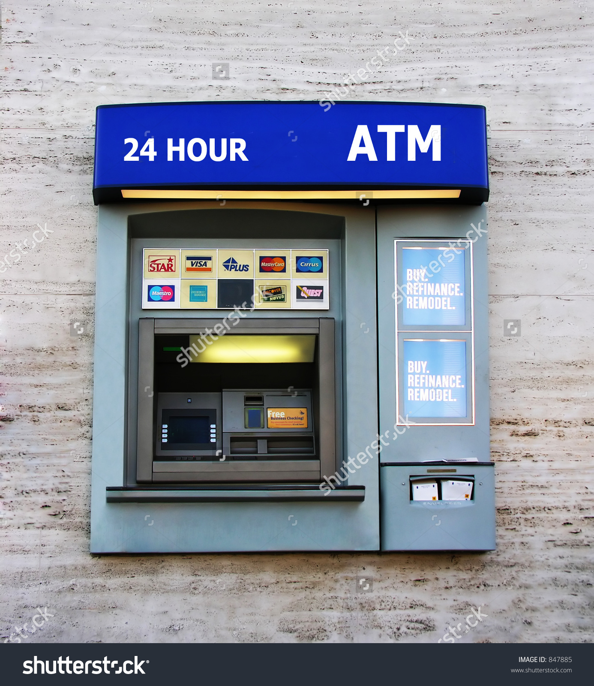

I pledge that this work is entirely mine, and mine alone (except for any code provided by my instructor).
I spent approximately 30 hours reading the assignment, writing the code for the ATM, learning Java FX for the GUI, and writing the GUI.

